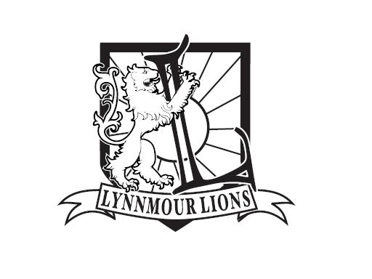
Lynnmour Elementary School

800 Forsman Ave. North Vancouver BC V7J 2G6

Telephone: 604-903-3590
E-Mail address: lynnmour@sd44.ca

ADMIN REPORT
Presented by Angela Meule

New information items:

Our school wide theme for the year:
We are continuing with Michele Borba’s Building Moral Intelligence: The Seven Essential Virtues that Teach Kids to Do the Right Thing (www.michelborba.com) Each class will be “presenting” a different virtue to the entire school each month. This may be in the form of an assembly, morning messages, a dramatic skit, mini presentations, making a video clip or movie clip – the possibilities are endless!
During the month of September, Ms. Keys class taught Lynnmour all about empathy. This month Mrs. Jensen’s class will teach the virtue of “fairness” to the other students.
Moral intelligence is the capacity to understand right from wrong; it means to have strong ethical convictions and to act on them so that one behaves in the right and honorable way. It consists of seven essential virtues. Building Moral Intelligence by Dr. Michele Borba (Jossey-Bass Publishers, 2001) provides a complete step-by-step plan for teaching kids these critical virtues they’ll need to do what’s right and resist any pressures that may defy the habits of good character. The seven virtues of moral intelligence include: empathy, conscience, self control, respect, kindness, tolerance and fairness.

Terry Fox Run:
Thank you to Mrs. Jensen and her Grade 1/2 class for coordinating this year’s Terry fox Run. We raised over $400 for Cancer Research! Lynnmour students and their families are continuing to keep Terry’s dream alive! Congratulations to all runners and thank you for your generous donations!

Lynnmour Athletics
Basketball season s well under way and we are well represented with our Gr. 7 Boys team. Thank you to Mr. Yuan for coaching our boys this season. The boys play every Monday afterschool here at Lynnmour, please feel free to stop by the gym and cheer on our team.
Sports Club
Coach Kristine has once again started Sports Club on Friday mornings. The circuit begins at 8:00 am and ends at 8:30. Student’s in K-3 are encouraged to participate in the club with our older students as leaders.

Christmas Cards
Once again Lynnmour has taken part in the Card Project. Students have created individualized Christmas Cards that will soon be available for purchase.

Great Shake Out BC!
We will be conducting our first Earthquake Preparedness Drill on Thursday, October 20th. Performing emergency drills and reviewing school emergency plans are important and necessary steps in becoming as prepared as possible for an emergency situation.

This is also a good opportunity to talk about being prepared for an emergency at home. The North Shore Emergency Management Office encourages everyone to create a family emergency plan and stock and maintain a basic home emergency kit. Supply lists for a basic home emergency kit can be found at http://nsemo.org/.

Australian Student Teachers:
Once again Lynnmour is excited to welcome our Australian student teachers. They arrive on Monday, October 24th and will be here until November 10^{h}. We are very fortunate to have a student teacher in Mrs. Jensen’s, Ms. Keys, Mrs. Zander’s and Mrs. Schafer’s classes. Please feel free to stop by to say hello!

Remembrance Day Assembly
Our assembly will be held on Thursday, November 10, 2014 at 10:50 am. Please feel free to join us! The Choir will be performing.

Standing Information Items:

Lynnmour’s School Handbook and Code of Conduct
An updated copy of our revised handbook and Code of Conduct is available on our website. A condensed version is located in the front of the student agendas.

Lynnmour School Plan

Our goals for this year are as follows; To improve the Thinking Competency of students in K-7 and To improve the Personal and Social Emotional Competency in students K-7. For the complete copy of Lynnmour's School Plan 2016-2017, please go to our website.

Calendar Updates:

Reminder of the Province Wide Professional Day this Friday, October 21, 2016
November 1, 2016 Professional Day

