It is time for another gift-card order!
Please support our school by going shopping and buying your groceries with gift cards again. Gift cards work like cash, and there is no additional cost for you, but a rebate goes back to the PAC automatically!

HOW DO I ORDER?

Collect orders from family and friends!
You can add their order to your order form, or you can ask us for a separate one.

Complete attached order form and drop it together with your payment into the PAC box located across the Kindergarten classroom. Payment can be made by cash or cheque payable to Lynnmour PAC.

ORDERS MUST BE RECEIVED BY
Wednesday, May 17th

Your order will ready for pick-up 1-2 weeks after the deadline. We will notify you when your order arrives and make sure it gets home safely.

Please note the current promotions: 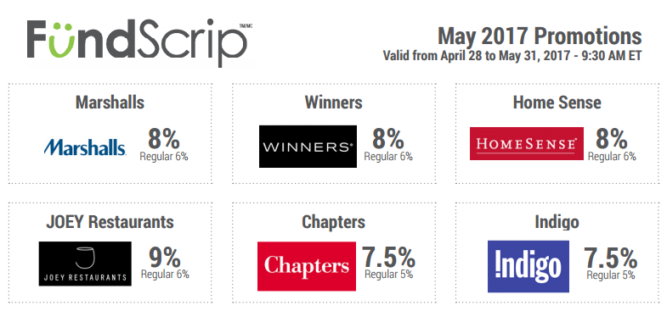
Thank you for supporting our school!

